

**Project**

**Project Title: Job Portal.**

Course Title: Web Database Programming

Course Code: **CSE480**

Section: **1**

**Submitted To**

**Abdus Satter**

Adjunct Faculty

Department of CSE

East West University

**Submitted By**

**Robayed Ashraf**

ID: **2018-1-60-238**

Department of CSE

East West University

**Submission date: May 18, 2021**

**Project Purpose**

Now a days, seeking job is very difficult online job portal. This project is made to overcome these difficulties. This is a complete platform for the employers and job seekers.

**Project Goals and Objectives**

* **The employer can post job for the job seekers.**
* **The employer can edit and delete jobs when necessary.**
* **The employer also can recruit employee from this portal.**
* **The job seekers can finds perfect jobs for them.**
* **The job seekers can also easily apply for job from this portal.**

**Project Description**

**The application Job Portal is mainly created to make an easy system for both employers and employees. By this application the employers and employees can complete their all necessary work like employee recruiting and job finding and applying for job and so on. It will helps the both party to overcome their problem easily.**

**Scope**

**This application can be used as complete job media.**

**System Users**

* **Admin: Has full authorization to this system.**
* **Job Seekers: Only can find jobs and apply for jobs.**
* **Employers: They can post, update, and delete jobs.**

**Database**

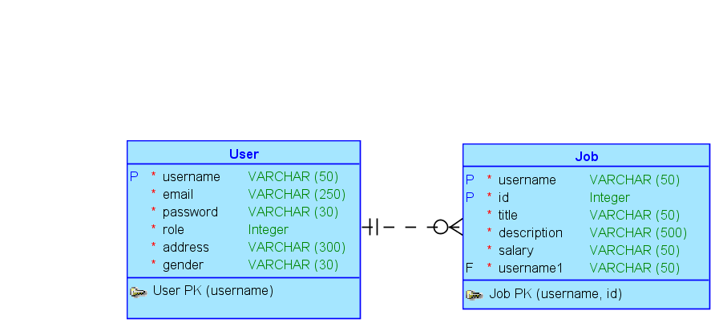

**Figure: ER Model for Job Portal Database.**

**Process**

* **Register: Anyone can register their account in this application. The applicants must choose their role for this application.**
* **Login: The users can directly login to their account. After login the users will see the features by correspondent to their role.**
* **Find Jobs: This option will only be available for admin and jobseekers. By this features jobseekers can find their perfect jobs and apply for them.**
* **Post Jobs: This feature will only be available for admin and employers. By this option the employers can post new jobs.**
* **Edit Jobs: This feature will only be available for admin and employers. By this option the employers can update and delete jobs posted by them.**
* **There are a few more processes available in this application.**

**Technologies:**

* **Frontend Language:** Html, PHP, CSS
* **Backend Language:** MySql Database, PHP